Oikos Project Update

Accomplished (Latest Sprint 12/2-12/9)

1. Populating graph with stored nodes in DynamoDB
2. Adding nodes populates to DynamoDB
3. Node positioning is saved and sent to DynamoDB as well so that refresh and populating node position with consistency

Accomplished (Fall 2024)

1. Full rework of the repository for easier navigation for future developers
2. Added buttons for users to create a new person or organization - as well as undo and redo buttons. The purpose of this was to help simplify for less experienced users

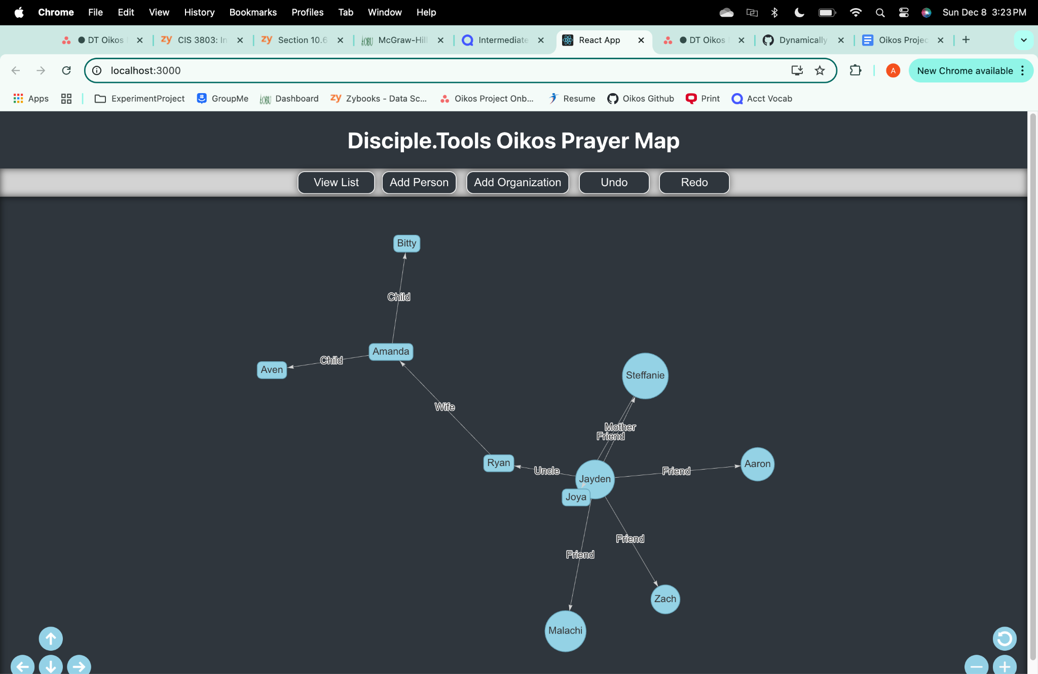

1. Being able to run the code on a single server (Node.js)
2. Beginning implementation of DynamoDB
3. Updates to UI for better visual appeal
4. Created a ‘Custom Field’ option for the user when creating a person or an organization

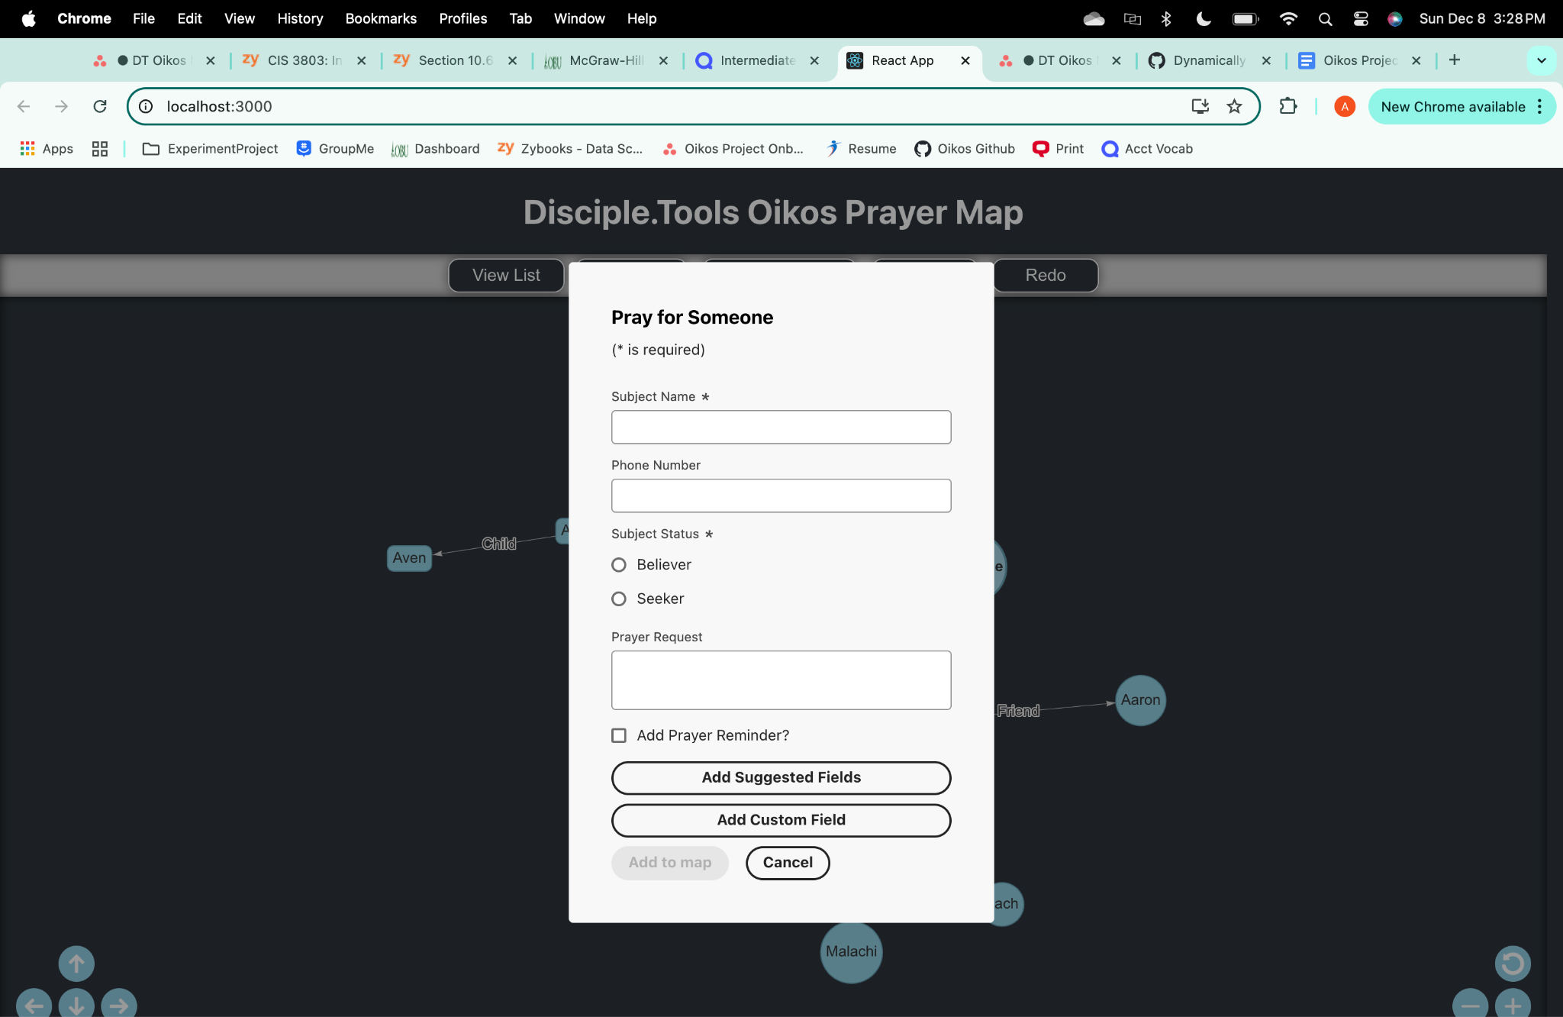

1. Ensuring visual and functional consistency between computer and mobile devices

Plans for Spring 2025 Semester

1. Undo/Redo button functionality
2. Complete DynamoDB implementation
3. Adding functionality to mobile device users (ex. pinch zoom capabilities, etc.)
4. Work toward implementing with DiscipleTools
5. Editing/Updating and Deleting nodes pushing to DynamoDB